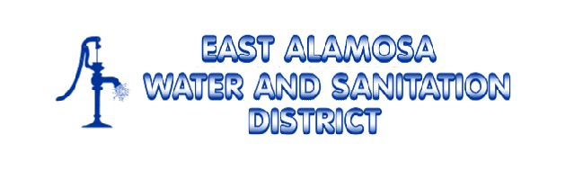
Application For
Water, Sewer Taps &
Water, Sewer Line Extensions
East Alamosa Water and Sanitation District
P.O. Box 1092 10 Costilla Blvd
719-589-2649

Utility you are applying for: WATER SEWER

Property Owner’s Name _______________________________________________________________________

Property Co-Owner’s Name ____________________________________________________________________
Service Address: _____________________________________________________________________________

Mailing Address: _____________________________________________________________________________

Phone Number: _________________________________ Email: _______________________________________

Location of property within the East Alamosa Water and Sanitation District (Give Lot Number, Block Number, Name of Subdivision, or other description of property to be connected to the system)
_______________________________________________________________________________________
_______________________________________________________________________________________

_______________________________________________________________________________________

SECTION A: SINGLE FAMILY UNIT
Water Service Connection Fees:
Residential Water Tap Fee | $3,072.25
Commercial Water Tap Fee | $4,608.38
Meter & Appurtenances Costs
Sewer Service Connection Fees:
Residential Sewer Tap Fee | $3,072.25
Commercial Sewer Tap Fee | $4,608.38

- Payment of tap fees does not include the cost of water meters, meter pit, and all expenses incurred in the connection of the customers service to the district’s main line. These additional expenses shall be paid by the customer before a permit for the use of the districts system is issued.
- Applicant is responsible for installation of water or sewer line from their structure to the water meter or main sewer line.
- Engineering Plans or a Statement from a Qualified Professional must be included with Application before approval from East Alamosa Board of Directors. Plans should specify the approximate location of the service line coming from the structure and confirmation of sufficient grade and elevation as pertains to wastewater lines.
- This application must be submitted in person by one of the named owners of the property for which services are requested.
- Tap Fees are due at time of application. Meter & Appurtenances costs will be billed upon installation.
- All Engineering costs that may be incurred by EAWSD in the study of plans submitted by the applicant will be the responsibility of the applicant.
- For additional information and EAWSD policies, please refer to the Rules & Regulations on the District website at eastalamosaws.org.
- This may not be a complete list of all fees involved. Road cuts, permits, commercial plumbing companies and contractors may result in additional charges.

Application for Service | $35.00
Water Tap
Sewer Tap
Water Meter
TOTAL:

SECTION B: PROPERTIES OTHER THAN SINGLE FAMILY UNIT

1. Applicant requests service availability letter from District Administrator.
2. District Administrator reviews the service area to determine if water and or sewer service is available to the property of the interested party. If available, the District’s Administrator sends a letter to Alamosa County Building Dept. stating water and or sewer service is available.

3. District Administrator informs interested party that once initial Alamosa County requirements are met, the interested party will meet with the district, pay the application fee of $35 and begin the application for permit process. The District’s board will review all the County approved plans. The District will require additional engineering plans to approve the project, including but not limited to; drawings which show the location of the service lines to the structure or structures as well as confirmation of sufficient grade and elevation pertaining to wastewater lines.
4. Once number of tap fees are determined upon the District’s Engineer’s recommendation and Board Approval of tap fees, a tap fee permit will be issued upon full payment of tap fees as well as any engineering fees incurred by the district. Meter and Appurtenance costs will be billed upon installation.

5. Upon full payment, application approval, and signed by the President of the Board of Directors, this application shall serve as the customer’s permit for water and or sewer taps.

Application for Service | $35.00
Water Tap
Sewer Tap
Water Meter
TOTAL:

_______________________ __________ _______________________ ________
Signature of Owner Date Signature of Co-Owner Date

Date Approved by Board of Directors ___________________

_____________________________________________
Signature of the President of the Board of Directors

